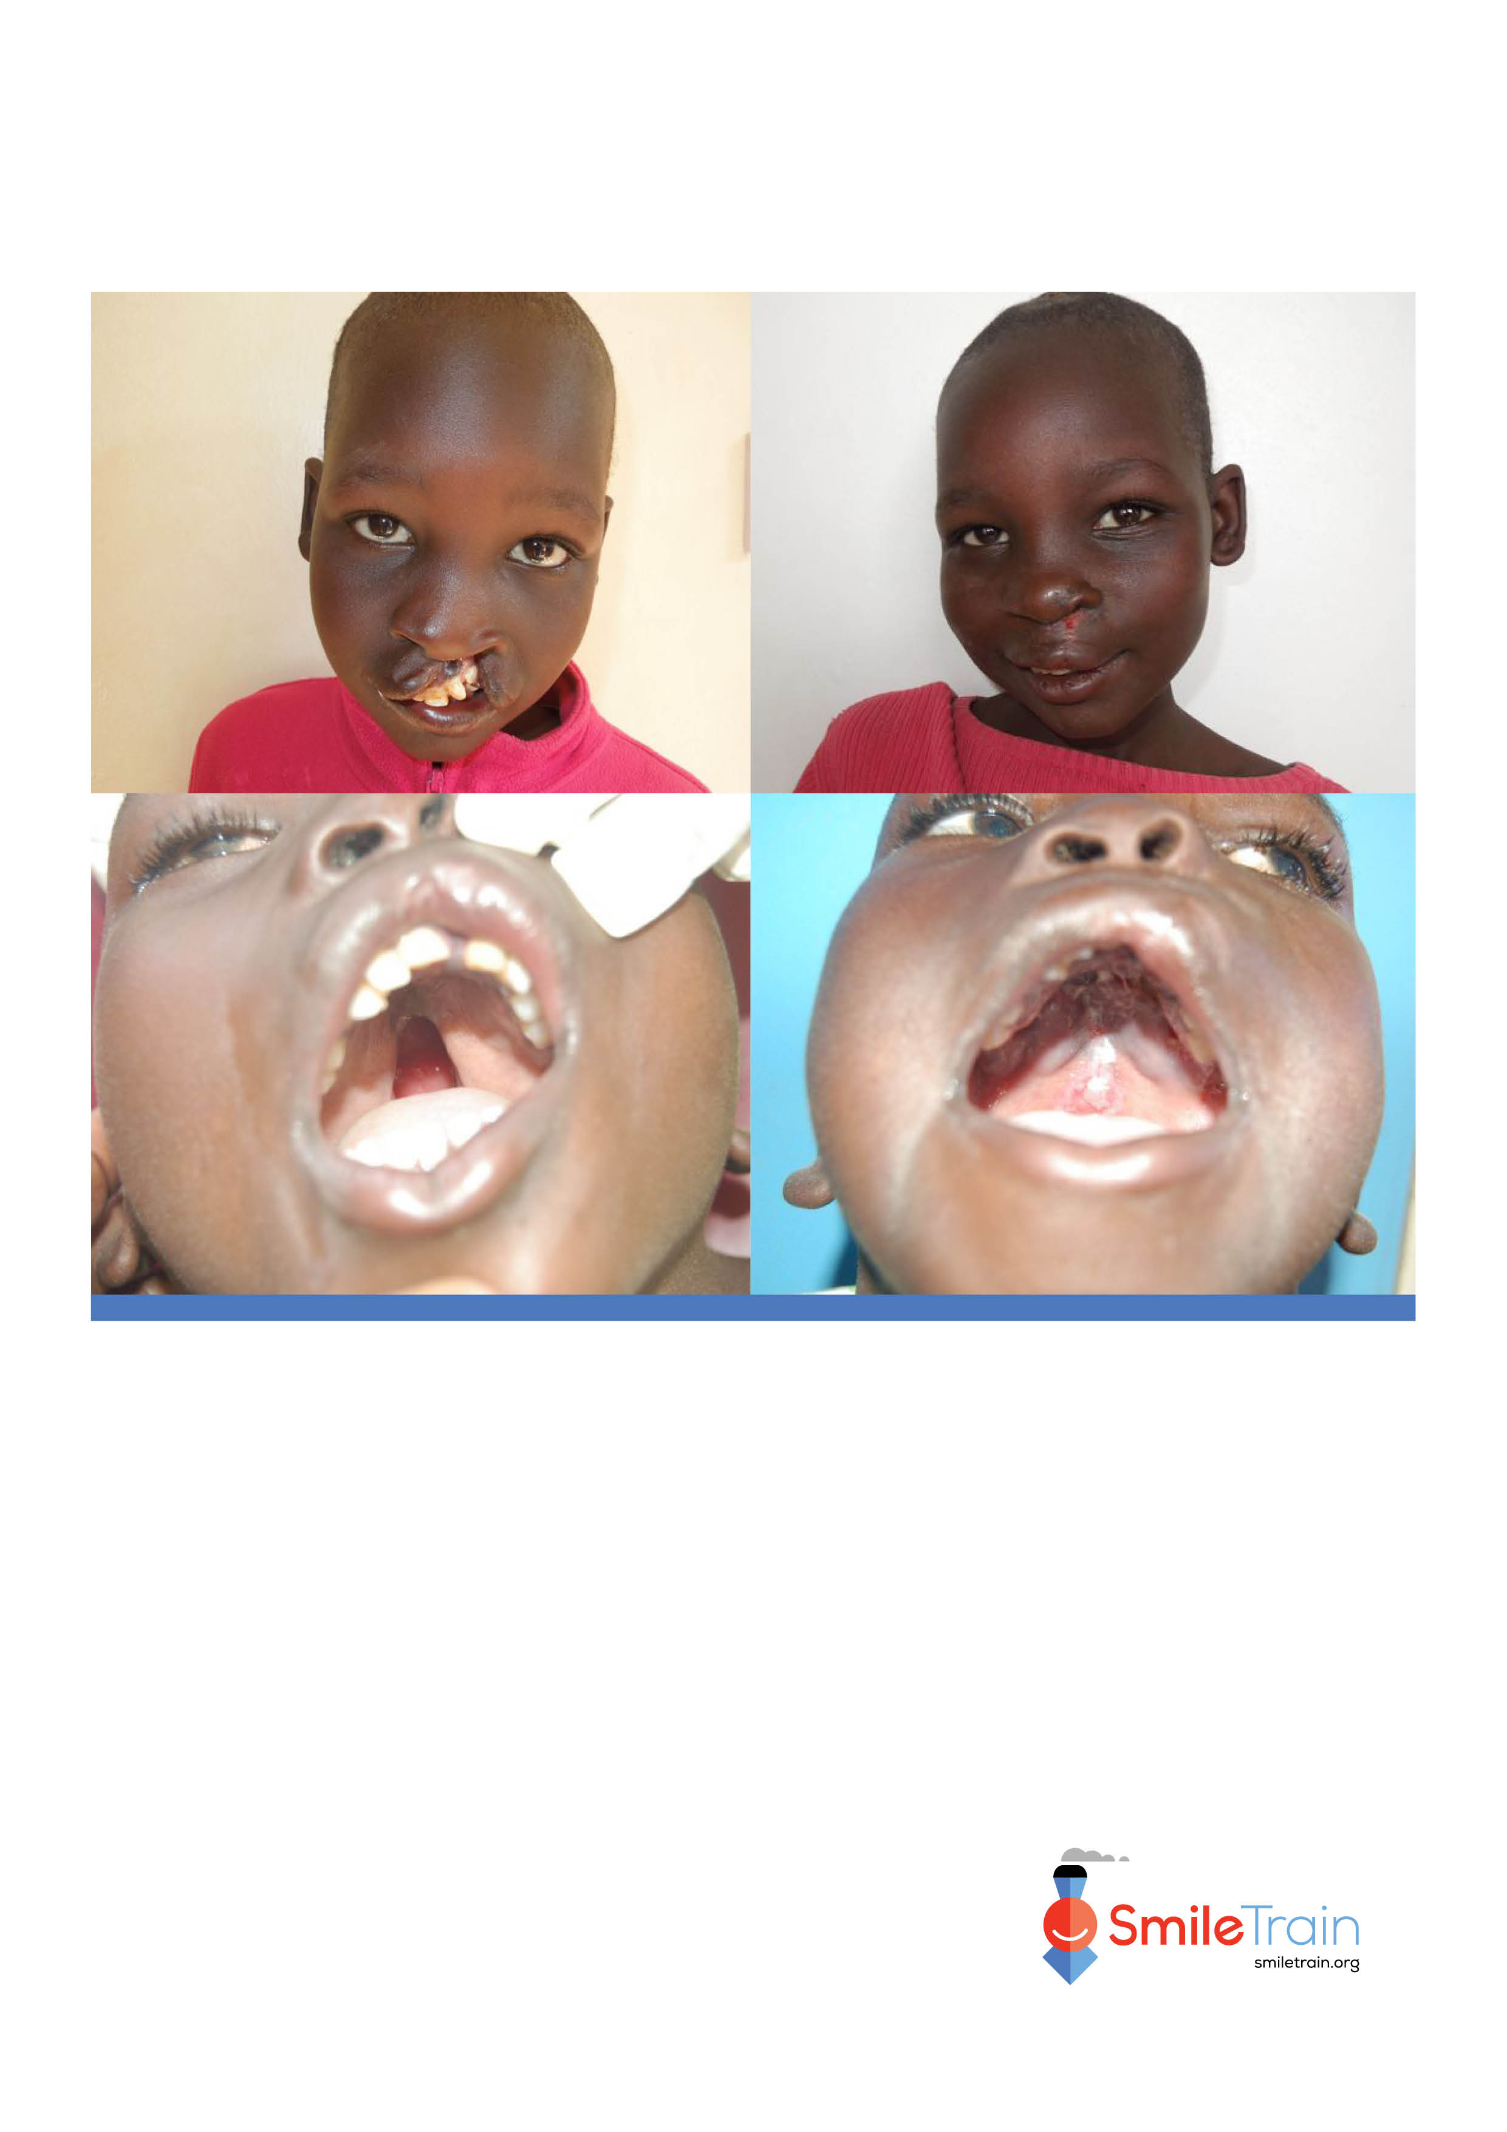

*Partner Logo Goes Here*

*(once inserted, delete this text box)*

*Transportation and/or lodging may also be provided at no cost to the patient.*

**Insert contact name here**

**Contact Name:**

**Insert contact details here**

**Contact Details:**

**Hospital Address:**

**Insert hospital address here**

**Hospital Name:**

**Insert hospital name here**

**Cleft lip and cleft palate are common and correctable. Smile Train can help!**

**FREE, HIGH-QUALITY SURGERY FOR CLEFT LIP AND CLEFT PALATE**